Finished Design Document

* Context scenario

**Context**: User need education related information and 99% of the time users search on google for any information. This website can be helpful for education related information. This website contains bunch of datasets of FAFSA, School surveys, and record of school career and technical programs. If any one need information related to these datasets, they can simply search for website and this website is user friendly. Many people feel long process of log in and signing in. They feel headache about it. User is not required to log in or sign in for this website. It is only for information so it will be direct on screen as soon as user click on website.

**Users:** Students, Parents, Teachers

**Goal:** To get education related information

**Task:** Look up for website

**Social Environments:** The website

**Physical Environments:** Home, school, office

**Resource:** Phone, laptop

I have heard of FAFSA program but I not sure how it works and how to apply for it. Let me google it

* Story Boards

I got admission in county college

That is great but I don’t earn that much money

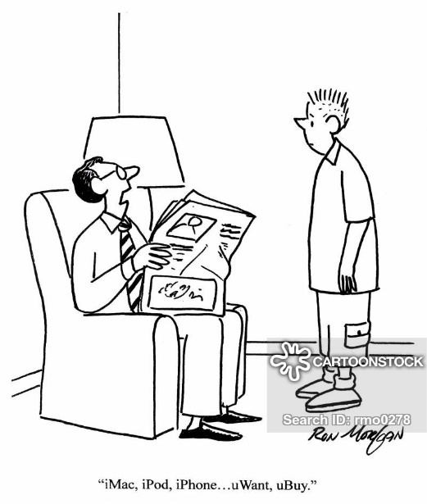



This website has all information. This is awesome.

Back

<https://catalog.data.gov/dataset/school-survey-on-crime-and-safety-2016>

<https://catalog.data.gov/dataset/free-application-for-federal-student-aid-2015-16>

<https://catalog.data.gov/dataset/career-and-technical-education-programs-in-public-school-districts-201617>

Career & technical education programs

School survey on crime & safety

FAFSA

Main Page

* Block Diagram

* Wireframe
* Style Guide

Logo



* Colors

I want to keep it very simple and professional

* Fonts

Times new roman (Because I want to keep it very simple and professional )

A B C D E F G H I J K L M N O P Q R S T U V W X Y Z

a b c d e f g h I j k l m n o p q r s t u v w x y z